**CookBook**

Son Minh Nguyen – SID:000433430

Matt Hilarry Caballero – SID: 000440554

Camille Soriano – SID: 000432489

**Purpose:**

* This website aims to be a one-stop website to search for a wide range of food recipes. In order to use the website, a user can either create an account or sign in as guest. Once signed in, the user can upload recipes and rate other recipes in the site.

**Web stack:**

* Linux
* NGINX
* MongoDB
* ExpressJS
* REACTJS
* NodeJS

     

Possible additional technologies:

* TypeScript
* GraphQL

 

**Update risk and issues:**

|  |  |  |
| --- | --- | --- |
| Day | Risks | Issues |
| Oct 13, 2021 | Team’s meeting gets canceled | Meeting delays |
| Oct 14, 2021 | Team’s meeting gets canceled, team member absent |  |
| Oct 20, 2021 |  | Shared document file was not accessible for all members. |
| Oct 218, 2021 | -Not finishing research for needed technologies.  -Not finishing the website wireframe. |  |
| Oct 22, 2021 | -Not finishing the document for milestone 1 |  |

**Youtube Demo Link:**

[CookBook - Milestone Report 1](https://youtu.be/rt2VeU9Fjzc)

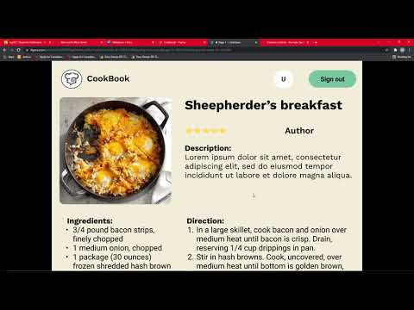

Note: My PC fan was really loud in the video and there was a line on my screen that I couldn’t remove

**Members’ tasks breakdown table**

|  |  |  |  |
| --- | --- | --- | --- |
| **Members** | **Task 1 - Wireframe** | **Task 2 - report** | **Status** |
| Matt | Login page, register page | #4 & #7 | **completed** |
| Son Minh | New recipe page, profile page, detail page, home page | #1, #2 & # 8 | **completed** |
| Camille |  | # 3 & #5 proof reading | **completed** |

**Plan Until Submission:**

* **Website API** 
  + To be finished on 1st to 2nd week of November
  + By Camille Soriano
* **Database Integration**
  + To be finished on 2nd or 3rd week of November
  + By Matt Caballero
* **Front-End Design**
  + To be finished 1 day before submission
  + By Son Minh Nguyen